PROGRAM 1
from matplotlib import pyplot as plt name=['arjun','naveen','rocky','reena'] mark=[51,87,45,67] plt.bar(name,mark,color='blue') plt.title('Result') plt.xlabel('Names') plt.ylabel('Mark') plt.show()

PROGRAM 4
import numpy as np import matplotlib.pyplot as plt def step_function(x):
return np.where(x >= 0, 1, 0) x = np.linspace(-10, 10, 400) y = step_function(x) plt.plot(x, y, color='blue') plt.title("Step Function in Neural Network") plt.xlabel('input') plt.ylabel('output') plt.ylim(-1.5, 1.5) plt.grid(True) plt.axhline(0, color='black', linewidth=0.5) plt.axvline(0, color='black', linewidth=0.5) plt.show()

OUTPUT 2
AND (0,1)=0
AND (1,1)=1
AND (1,0)=0
AND (0,0)=0

PROGRAM 2
import numpy as np def unitstep(v): if v>=0: return 1 else:
return 0
def preceptronmodel(x,w,b):
x=np.dot(x,w)+b y=unitstep(x) return y
def ANDfunction(x): w=np.array([1,1]) b=-1.5 return preceptronmodel(x,w,b) test1=np.array([0,1]) test2=np.array([1,1]) test3=np.array([1,0]) test4=np.array([0,0]) print("AND({},{})={}".format(0,1,ANDfunction(test1))) print("AND ({},{})={}".format(1,1,ANDfunction(test2))) print("AND ({},{})={}".format(1,0,ANDfunction(test3))) print("AND ({},{})={}".format(0,0,ANDfunction(test4))) PROGRAM 3
import numpy as np input=np.array([0,5]) weight=np.array([1,1.5]) bias=-0.8 input*weight np.sum(input*weight)+bias

PROGRAM 5 OUTPUT 1
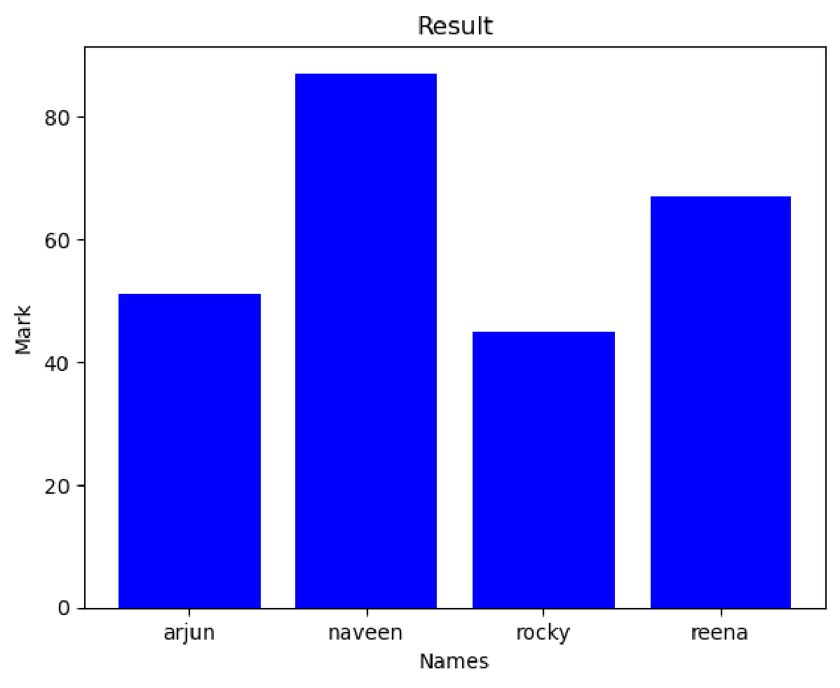
import numpy as np import matplotlib.pyplot as plt x=np.arange(-10,10,0.1) y=1/(1+np.exp(-x))
plt.plot(x,y,'g') plt.grid(True) plt.axhline(y=0.5,color='green',linestyle=':') plt.xlabel('Input') plt.ylabel('Output') plt.title('Graph of the Sigmoid Function')
plt.show() OUTPUT 5
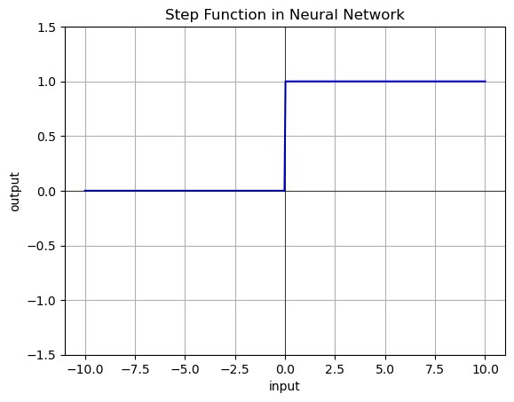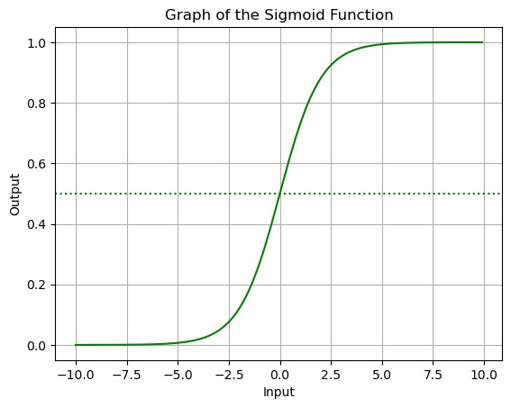

OUTPUT 4

OUTPUT 3:
6.7

